I learned quite a bit during this first critical thinking assignment, the most important in my opinion was learning to have a good base of fundamentals. I really enjoyed going back and re-learning some of the programming basics because if I’m being honest, I forgot a lot of them, I think most people do. I realized just how important learning the fundamentals is, and not only that but how important it is to keep practicing them. A specific example would be writing small chunks of code and then executing them (​​Lysecky & Vahid, 2019, section 1.6). It sounds so small and simple, but it’s a very good practice that we should all continue to practice well into our career. I completed the assignment by asking the user for numbers and then casting them to ints, in order to be able to perform arithmetic on them. I then printed the results.

**Git:**

https://github.com/Sabathrodriguez/grad_school/tree/main/csc500-1

**Output Screenshot:**

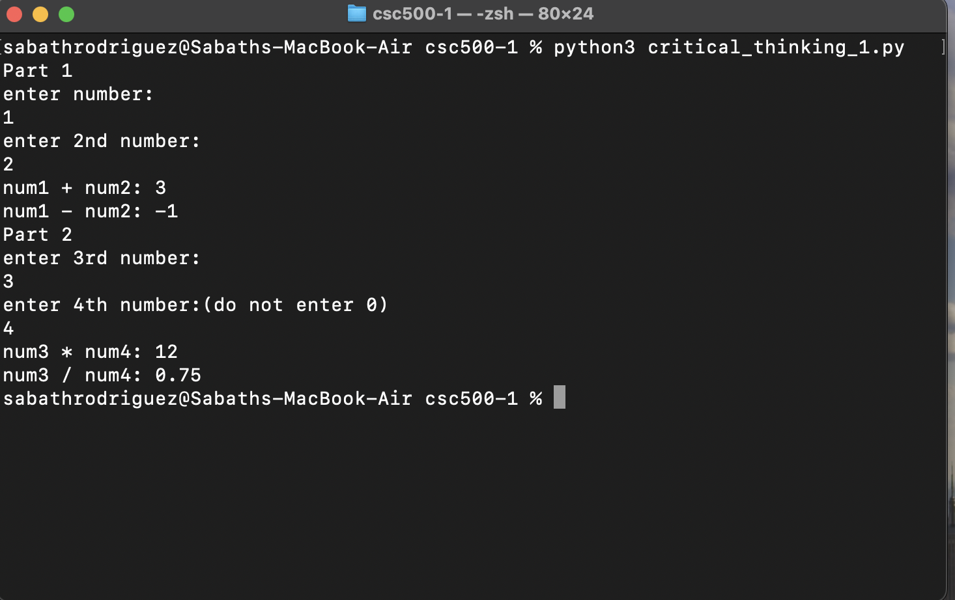

References

1. Lysecky, R., & Vahid, F. (n.d.). 1.6 Errors. In *CSC500: Principles of Programming*. essay, ZyBooks.